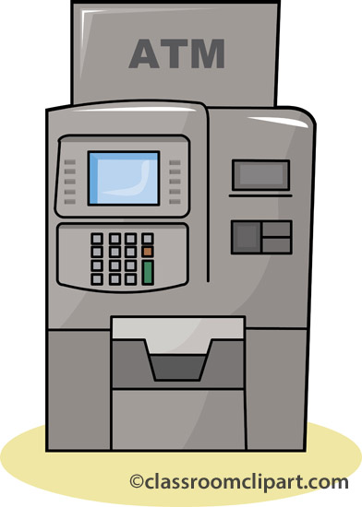

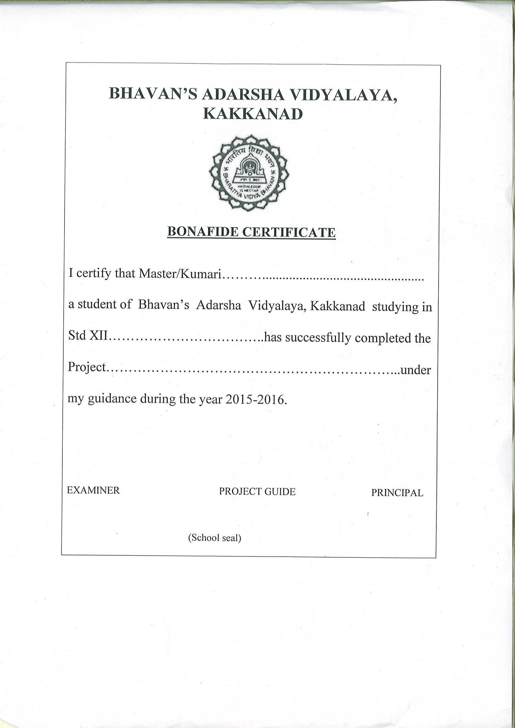CERTIFICATE

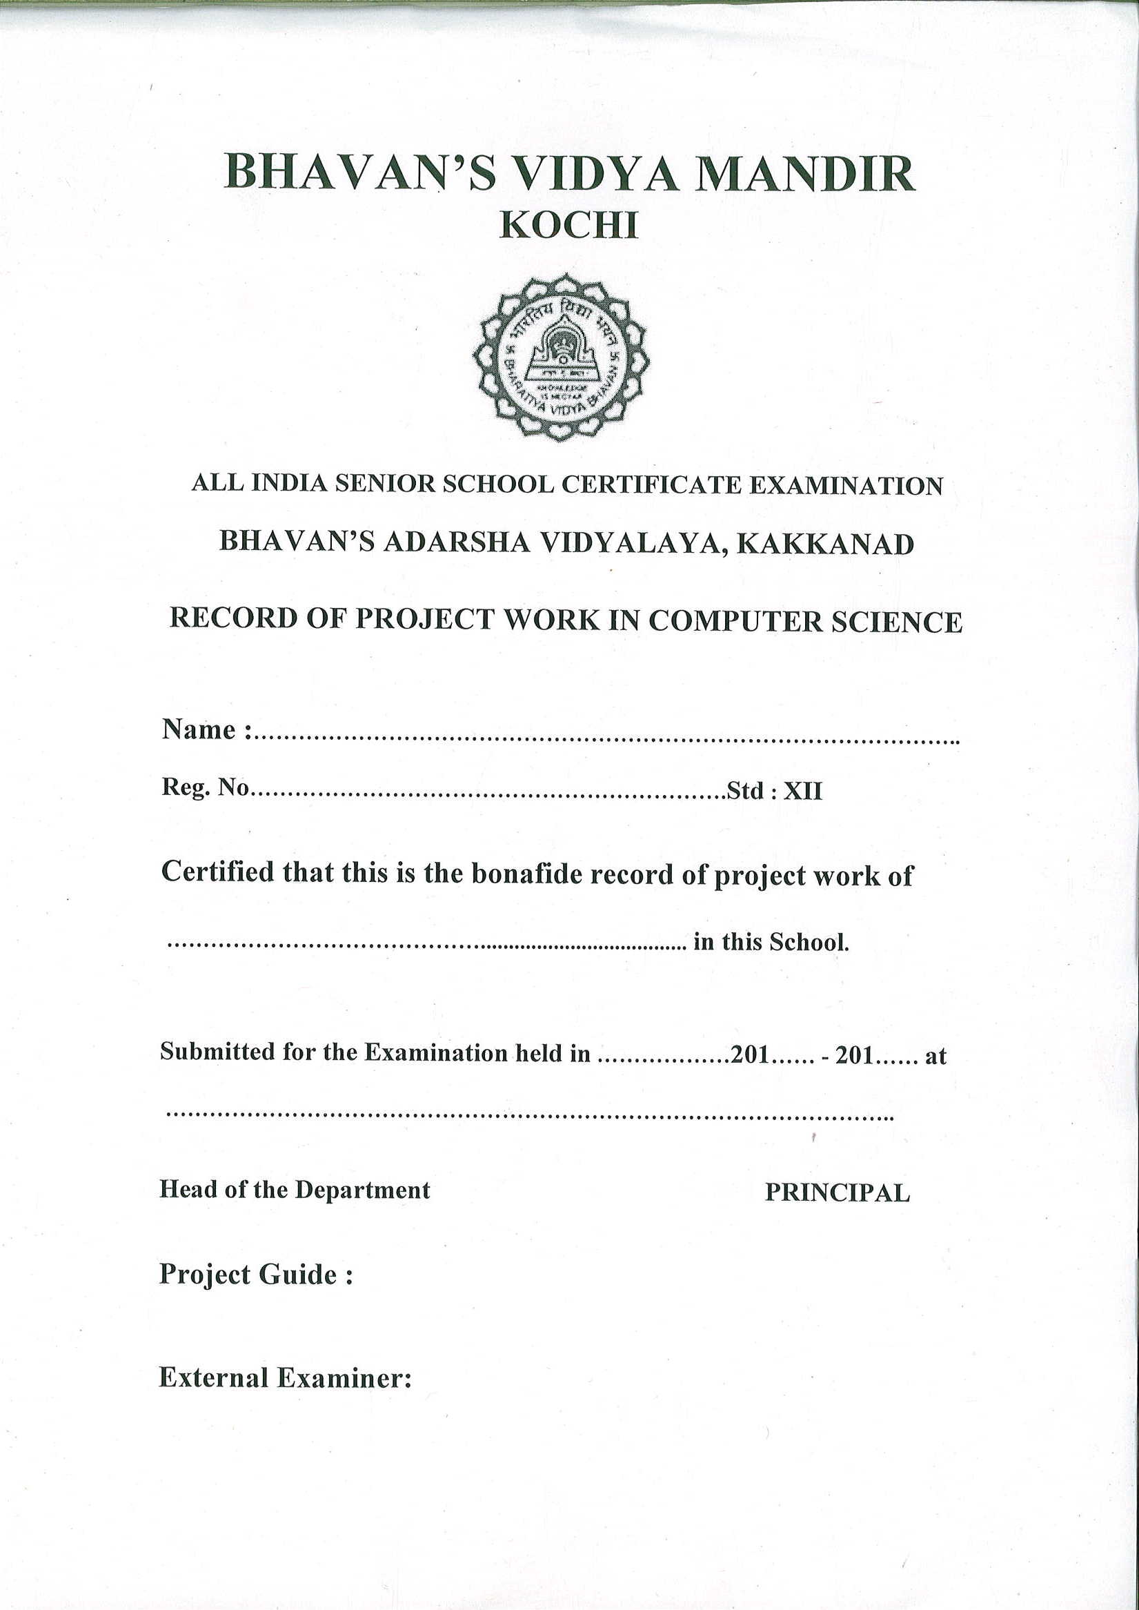

ACKNOWLEDGEMENT

I would like to thank God Almighty for giving me his blessings to complete this project on time. I would like to express my sincere thanks to my parents for their support and encouragement.

I would like to express my sincere gratitude to Principal Madam Smt. Sukumari Menon and Vice-Principal Madam Parvathy E for giving me an opportunity to do this project and also allowing me to use the lab during the course of the completion of the project. I would like to convey my special thanks to our computer teachers Seema miss and Meera miss for giving us the support necessary to complete this project.

CONTENTS

|  |  |  |
| --- | --- | --- |
| Sl No | Topic | Page No. |
| 1 | Overview of C++ | 6 |
| 2 | Need for the Project | 7-8 |
| 3 | Hard ware and software requirements | 9 |
| 4 | System Graph | 10 |
| 5 | Header files used | 11 |
| 6 | User defined functions/class/files | 12 |
| 7 | Source code | 13-36 |
| 8 | Output | 37-44 |
| 9 | Short comings of the project | 45 |
| 10 | Bibliography | 46 |
|  |  |  |

OVERVIEW OF C++

**C++** ([pronounced](https://en.wikipedia.org/wiki/English_alphabet#Letter_names) as cee plus plus) is a general-purpose [programming language](https://en.wikipedia.org/wiki/Programming_language). It has [imperative](https://en.wikipedia.org/wiki/Imperative_programming), [object-oriented](https://en.wikipedia.org/wiki/Object-oriented_programming) and [generic](https://en.wikipedia.org/wiki/Generic_programming) programming features, while also providing facilities for low-level memory manipulation. C++ was developed by [Bjarne Stroustrup](https://en.wikipedia.org/wiki/Bjarne_Stroustrup) at [Bell Labs](https://en.wikipedia.org/wiki/Bell_Labs) since 1979, as an extension of the [C language](https://en.wikipedia.org/wiki/C_(programming_language)) as he wanted an efficient and flexible language similar to C, which also provided high-level features for program organization.

It was designed with a bias toward [system programming](https://en.wikipedia.org/wiki/System_programming) and embedded, resource-constrained and large systems, with performance, efficiency and flexibility of use as its design highlights. C++ has also been found useful in many other contexts, with key strengths being software infrastructure and resource-constrained applications,including [desktop applications](https://en.wikipedia.org/wiki/Application_software), servers (e.g. [E-commerce](https://en.wikipedia.org/wiki/E-commerce), [web search](https://en.wikipedia.org/wiki/Web_search_engine) or [SQL](https://en.wikipedia.org/wiki/SQL) servers), and performance-critical applications (e.g. [Telephone switches](https://en.wikipedia.org/wiki/Telephone_switches) or [space probes](https://en.wikipedia.org/wiki/Space_probes)).

According to Stroustrup, "the name signifies the evolutionary nature of the changes from C".This name is credited to Rick Mascitti. It is driven by actual problems and its features are useful immediately in real world programs.

NEED FOR THE PROJECT

As the world progresses on in this never ending chase for a time and wealth, it is undeniable that science has made astounding developments.

As the 21st century looms ahead, it is clear to see that it has advancements that humanity may never have dreamed of and one of these shining developments is the well-recognized computer. Having the Latin meaning of ‘computing’ or ‘reckoning’ the computer is an invention that was called the ‘MAN OF THE YEAR’ in a survey carried out by an international magazine.

The computer system is not a simple machine. It is like a very modern and highly complex calculator. It can do all the functions at a speedy rate and also helps us to search and progress in our homes and businesses. A computer can therefore be called a calculator with a twist for not only does it perform fast calculations, but it also has other special characteristics. And equally important are the programming languages available in these computers.

In this busy world, computers and other machines which do our job form an inevitable part of our lives. An ATM (automated teller machine) is one such machine. It helps us to get cash instantly at our fingertips from any corner of the world and hence it is a machine of vital importance.

Our project program is an effort to replicate the software of an ATM system.

The key features of the program include separate working graphical working environments for customers and the bank officials, 4-digit pin protection for customers use and password protection for official use, high performance, fast transaction etc.

To start the program you must double-click on the icon of Turbo C++ in the desktop or select Turbo C++ from the start menu. When C++ opens up, open the program PROJECT.

Select Run. You will see the startup menu of the atm. If you select Customer, you will be asked to type your 4-digit ATM pin number. If that is done successfully, you will encounter a menu showing you the various options you have as a customer. If you select Balance Enquiry, it will display all your details by calling the putbank() function. If you select Withdrawal it will allow you to withdraw an amount less than Rs.50000 using the withdraw() function. If you select Change Settings, it will display another menu asking whether to change the name, account number, or pin number. Corresponding choices will call the corresponding functions and your details can be changed. If you select Exit, you will reach the startup page again.

Now, if you select Bank Official you will be asked the user id and password. On entering these two correctly, you will encounter a menu showing you the various options. If you select Add account holders, it helps you add new account holders to the list by calling the getbank() function. If you select change user id and password, you can change your id and password. If you select deposit cash in machine, it allows you to increase the grand balance of the ATM machine. If you select Display present cash status, it shows the remaining amount of money in the ATM. If you select change cash limit, it allows you to change the limit regarding the maximum amount of money that can be withdrawn. If you select Exit, you will come back to the startup page.

If you select EXIT, you will come out of the program.

HARDWARE AND SOFTWARE SPECIFICATION

HARDWARE

Processor : Intel®core™ i5 [m450@2.40gHz](mailto:m450@2.40gHz)

Installed memory (RAM) : 4.00 GB DDA3

Storage HDD capacity : 500GB

SOFTWARE

Operating system : Windows 7 Professional/Linux

Turbo C++

SYSTEM GRAPH

ATM

3. HELP

2. BANK OFFICIAL

4. EXIT

1. CUSTOMER

1. Balance Enquiry

2. Cash Withdrawal

3. Change settings

4. Exit

HEADER FILES USED

fstream.h - for cout, cin, file manipulation (read and write)

conio.h - for clrscr() and getch()

stdio.h - for gets() and puts()

graphics.h - for initgraph(),outtextxy()

dos.h - for delay()

string.h - for strcpy(),strcmpi() etc.

process.h - for exit(0)

FUNCTIONS/CLASSES/FILES

CLASSES - class bank

FILES - atminfo.dat

FUNCTIONS - void bank::getbank()

void bank::putbank()

void bank::deposit(double)

void bank::withdraw(double)

char* bank::access()

char* bank::retpinno()

void bank::changename(char [])

void bank::changeacno(char[])

void bank::changepinno(char[])

void loading()

void help()

void customer()

void official()

void main()

SOURCE CODE

/* This is our project program and the aim of the program is

to replicate an atm system */

//Header files:

#include<fstream.h>

#include<conio.h>

#include<stdio.h>

#include<graphics.h>

#include<dos.h>

#include<string.h>

#include<process.h>

//Global variables:

int n;

long double grandbal=2500000,cashlim=50000,newlim; //Global variables

char uid[20]={'a','d','m','i','n','\0'};

char pwd[20]={'a','d','m','i','n','\0'};

//Global class definition

class bank

{

char name[25];

char acno[15];

char pinno[5];

double bamt;

public:

void getbank();

void putbank();

void deposit(double);

void withdraw(double);

char* access();

char* retpinno();

void changename(char[]);

void changeacno(char[]);

void changepinno(char[]);

}b[15];

void loading();

//Member function to accept values

void bank::getbank()

{

cout<<"\nEnter your name"<<endl;

gets(name);

cout<<"\nEnter your 10-digit account number"<<endl;

gets(acno);

cout<<"Enter the ATM pin number"<<endl;

gets(pinno);

cout<<"\nEnter your balance amount"<<endl;

cin>>bamt;

}

//Member function to display values

void bank::putbank()

{

int x=170,i,gdriver=DETECT,gmode;

initgraph(&gdriver, &gmode, "C:\\turboc3\\bgi");

outtextxy(15,15," ");

cout<<"\nName is\n";

puts(name);

cout<<"\nYour account number is"<<endl;

cout<<acno;

cout<<"\nYour ATM pin number is"<<endl;

cout<<pinno;

cout<<"\nThe balance amount is"<<endl;

cout<<bamt;

}

//Member function to carry out deposit

void bank::deposit(double amt)

{

bamt+=amt;

}

//Member function to carry out withdrawal

void bank::withdraw(double amt)

{

if((amt<=bamt)&&(amt<=cashlim))

{

bamt-=amt;

grandbal-=amt;

cout<<"\n\n\n\n\n\n\n\n\n\n\t\tYOUR TRANSACTION IS BEING PROCESSED...";

delay(10000);

cout<<"\n\n\n\n\n\n\n\n\t\t\tYOUR TRANSACTION IS COMPLETE";

cout<<"\n\n\t\t\t\tDON'T FORGET TO COLLECT YOUR CASH!";

delay(5000);

}

else

{

cout<<"\n\n\n\nSorry.The amount you entered is greater than your balance or the cash limit. Your transaction cannot be carried out";

delay(5000);

}

}

//Member function to return account number

char* bank::access()

{

return acno;

}

//Member function to return pin number

char* bank::retpinno()

{

return pinno;

}

//Member function to change name

void bank::changename(char newname[25])

{

strcpy(name,newname);

}

//Member function to change account number

void bank::changeacno(char newacno[])

{

strcpy(acno,newacno);

}

//Member function to change pin number

void bank::changepinno(char newpinno[])

{

strcpy(pinno,newpinno);

}

//Function to display loading bar

void loading()

{

clrscr();

int x=170,i,gdriver=DETECT,gmode;

initgraph(&gdriver, &gmode, "C:\\turboc3\\bgi");

setbkcolor(BLUE);

setcolor(RED);

settextstyle(DEFAULT_FONT,HORIZ_DIR,2);

outtextxy(170,180,"LOADING,PLEASE WAIT");

for(i=0;i<300;++i)

{

delay(5);

line(x,200,x,220);

x++;

}

settextstyle(DEFAULT_FONT,HORIZ_DIR,2);

outtextxy(190,250,"LOADING COMPLETE");

settextstyle(DEFAULT_FONT,HORIZ_DIR,2);

outtextxy(140,275,"PRESS ENTER TO CONTINUE");

getch();

closegraph();

}

//Function to explain the contents of the program

void help()

{

loading();

cout<<"\nINSTRUCTIONS:";

cout<<"\nIf you select Customer, you will be asked to type your 4-digit ATM pin number.";

cout<<" If that is done successfully, you will encounter a menu showing you the various options you have as a customer.";

cout<<" If you select Balance Enquiry, it will display all your details by calling the putbank() function.";

cout<<" If you select Withdrawal it will allow you to withdraw an amount less than Rs.50000 using the withdraw() function.";

cout<<" If you select Change Settings, it will display another menu asking whether to change the name, account number, or pin number.";

cout<<" Corresponding choices will call the corresponding functions and your details can be changed.";

cout<<" If you select Exit, you will reach the startup page again.";

cout<<"\n\nNow, if you select Bank Official you will be asked the user id and password.";

cout<<" On entering these two correctly, you will encounter a menu showing you the various options.";

cout<<" If you select Add account holders, it helps you add new account holders to the list by calling the getbank() function.";

cout<<" If you select change user id and password, you can change your id and password.";

cout<<" If you select deposit cash in machine, it allows you to increase the grand balance of the ATM machine.";

cout<<" If you select Display present cash status, it shows the remaining amount of money in the ATM.";

cout<<" If you select change cash limit, it allows you to change the limit regarding the maximum amount of money that can be withdrawn.";

cout<<" If you select Exit, you will come back to the startup page.";

cout<<"\n\nIf you select EXIT, you will come out of the program.";

return;

}

//Function to caary out the operations for a customer

void customer()

{

double amt;

char newname[25];

char newacno[15],ac[15];

char pin[5],newpinno[5];;

int j,ch3,flag=0,flag2=0,ch4,pos,pos2;

ifstream fin("atminfo.dat",ios::binary);

ofstream fout1("atminfo.dat",ios::binary||ios::app);

again4:

cout<<"\n\n\t\tENTER YOUR 4 DIGIT ATM PIN NUMBER\n\n\t";

for(int q=0;q<4;q++)

{

pin[q]=getch();

cout<<"*";

}

pin[q]='\0';

delay(1000);

while(fin.read((char*)&b[j],sizeof(bank)))

{

if(strcmpi(pin,b[j].retpinno())==0)

{

flag=1;

pos=j;

again5:

loading();

int x=170,i,gdriver=DETECT,gmode;

initgraph(&gdriver, &gmode, "C:\\turboc3\\bgi");

setbkcolor(RED);

setcolor(BLUE);

settextstyle(DEFAULT_FONT,HORIZ_DIR,2);

outtextxy(160,50,"WELCOME!!!");

settextstyle(DEFAULT_FONT,HORIZ_DIR,2);

outtextxy(100,80,"SELECT WHAT YOU WANT TO DO:");

settextstyle(DEFAULT_FONT,HORIZ_DIR,2);

outtextxy(5,130,"1.Balance Enquiry");

settextstyle(DEFAULT_FONT,HORIZ_DIR,2);

outtextxy(350,130,"2.Cash Withdrawal");

settextstyle(DEFAULT_FONT,HORIZ_DIR,2);

outtextxy(5,160,"3.Change Settings");

settextstyle(DEFAULT_FONT,HORIZ_DIR,2);

outtextxy(350,160,"4.Exit");

settextstyle(DEFAULT_FONT,HORIZ_DIR,2);

outtextxy(50,220,"ENTER YOUR CHOICE");

cout<<"\n\n\n\n\n\n\n\n\n\n\n\n\n\n\n\n\n\n\n\n\t\t";

cin>>ch3;

switch(ch3)

{

case 1: loading();

b[j].putbank();

delay(10000);

goto again5;

case 2: loading();

again9:

clrscr();

x=170,i,gdriver=DETECT,gmode;

initgraph(&gdriver, &gmode, "C:\\turboc3\\bgi");

settextstyle(DEFAULT_FONT,HORIZ_DIR,2);

outtextxy(50,50,"Enter the amount to be withdrawn");

cout<<"\n\n\n\n\n\n\t\t";

cin>>amt;

long t1=amt/100;

long t2=t1*100;

if((amt-t2)!=0)

{

cout<<"\n\nPlease enter an amount in multiples of 100";

delay(5000);

goto again9;

}

clrscr();

b[j].withdraw(amt);

fout1.write((char*)&b[j],sizeof(bank));

goto again5;

case 3: loading();

clrscr();

again6:

x=170,i,gdriver=DETECT,gmode;

initgraph(&gdriver, &gmode, "C:\\turboc3\\bgi");

settextstyle(DEFAULT_FONT,HORIZ_DIR,2);

outtextxy(50,50,"SELECT WHAT YOU WANT TO CHANGE");

settextstyle(DEFAULT_FONT,HORIZ_DIR,2);

outtextxy(75,120,"1.Name");

settextstyle(DEFAULT_FONT,HORIZ_DIR,2);

outtextxy(75,140,"2.Account Number");

settextstyle(DEFAULT_FONT,HORIZ_DIR,2);

outtextxy(75,160,"3.Pin number");

settextstyle(DEFAULT_FONT,HORIZ_DIR,2);

outtextxy(75,180,"4.Exit");

cout<<"\n\n\n\n\n\n\n\n\n\n\n\n\n\n\n\t";

cin>>ch4;

switch(ch4)

{

case 1: x=170,i,gdriver=DETECT,gmode;

initgraph(&gdriver, &gmode, "C:\\turboc3\\bgi");

settextstyle(DEFAULT_FONT,HORIZ_DIR,2);

outtextxy(125,75,"Enter your new name");

cout<<"\n\n\n\n\n\n\n\n\n\t\t";

gets(newname);

b[j].changename(newname);

fout1.write((char*)&b[j],sizeof(bank));

loading();

goto again6;

case 2: x=170,i,gdriver=DETECT,gmode;

initgraph(&gdriver, &gmode, "C:\\turboc3\\bgi");

settextstyle(DEFAULT_FONT,HORIZ_DIR,2);

outtextxy(125,75,"Enter your new account number");

cout<<"\n\n\n\n\n\n\n\n\n\t\t";

gets(newacno);

b[j].changeacno(newacno);

fout1.write((char*)&b[j],sizeof(bank));

loading();

goto again6;

case 3: x=170,i,gdriver=DETECT,gmode;

initgraph(&gdriver, &gmode, "C:\\turboc3\\bgi");

settextstyle(DEFAULT_FONT,HORIZ_DIR,2);

outtextxy(125,75,"Enter your new ATM pin number");

cout<<"\n\n\n\n\n\n\n\n\n\t\t";

for(int s=0;s<4;s++)

{

newpinno[s]=getch();

cout<<"*";

}

newpinno[s]='\0';

b[j].changepinno(newpinno);

fout1.write((char*)&b[j],sizeof(bank));

loading();

goto again6;

case 4: goto again5;

default:x=170,i,gdriver=DETECT,gmode;

initgraph(&gdriver, &gmode, "C:\\turboc3\\bgi");

settextstyle(DEFAULT_FONT,HORIZ_DIR,2);

outtextxy(125,75,"Sorry, wrong choice. Go again ");

goto again6;

}

case 4: return;

default: cout<<"Sorry, Wrong choice. Go again";

delay(4000);

goto again5;

}

}

}

fin.close();

fout1.close();

if(flag==0)

{

clrscr();

cout<<"\n\n\n\n\t\t!!!SORRY, Pin number doesn't exist...!!!";

delay(3500);

return;

}

}

//Member function to carry out operations for a bank official

void official()

{

int i,ch2;

long double dep;

char uide[20],pwde[20],nuid[20],npwd[20];

again2:

cout<<"\n\n\n\n\t\t\tENTER USER ID\n\t\t\t";

gets(uide);

cout<<"\n\n\t\t\tENTER PASSWORD\n\t\t\t";

for(int h=0;h<strlen(pwd);h++)

{

pwde[h]=getch();

cout<<"*";

}

pwde[h]='\0';

delay(1000);

if((strcmpi(uid,uide)!=0)||(strcmpi(pwd,pwde)!=0))

{

clrscr();

cout<<"\n\n\n\t\tTHE DATA YOU ENTERED IS INVALID.TRY AGAIN";

goto again2;

}

else

{

loading();

again3:

ofstream fout("atminfo.dat",ios::binary||ios::app);

clrscr();

cout<<"\n\n\n\n\tYOUR LOGIN WAS SUCCESSFUL!\n";

cout<<"\n\n\n\n\t\tWHAT DO YOU WANT TO DO?\n";

cout<<"\n\t\t\t1.Add account holders";

cout<<"\n\t\t\t2.Change user id and password";

cout<<"\n\t\t\t3.Deposit cash in machine";

cout<<"\n\t\t\t4.Display present cash status";

cout<<"\n\t\t\t5.Change maximum cash limit";

cout<<"\n\t\t\t6.Exit";

cout<<"\n\tEnter your choice\n";

cin>>ch2;

switch(ch2)

{

case 1: loading();

clrscr();

cout<<"\nEnter the number of account holders"<<endl;

cin>>n;

cout<<"Enter the details one by one..."<<endl;

for(i=0;i<n;i++)

{

cout<<"\nEnter the details of the "<<i+1<<"th account holder"<<endl;

b[i].getbank();

fout.write((char*)&b[i],sizeof(bank));

}

goto again3;

case 2: loading();

clrscr();

cout<<"\n\n\n\t\t\tENTER NEW USER ID\n";

gets(nuid);

strcpy(uid,nuid);

cout<<"\n\n\t\t\tENTER NEW PASSWORD\n";

gets(npwd);

strcpy(pwd,npwd);

goto again3;

case 3: loading();

clrscr();

cout<<"\n\n\n\n\t\tENTER THE AMOUNT YOU WANT TO DEPOSIT\n\t\t";

cin>>dep;

grandbal+=dep;

goto again3;

case 4: loading();

cout<<"\n\n\n\n\n\n\n\n\n\t\t\tTHE AVAILABLE BALANCE IS\n\t\t\t\tRs."<<grandbal;

delay(5000);

goto again3;

case 5: loading();

clrscr();

cout<<"\n\n\n\n\t\t\t\tENTER NEW CASH LIMIT\n";

cin>>newlim;

cashlim=newlim;

goto again3;

case 6: break;

default:loading();

clrscr();

cout<<"\n\n\n\n\t\t\t\tWrong choice. Go again";

goto again3;

}

fout.close();

}

}

//Main function

void main()

{

clrscr();

char ch2;

int ch1,j,flag;

long acn,ac;

double amtt;

int x=170,i,gdriver=DETECT,gmode;

again:

ifstream fin("atminfo.dat");

fin.read((char*)&b,sizeof(b));

fin.close();

initgraph(&gdriver, &gmode, "C:\\turboc3\\bgi");

settextstyle(DEFAULT_FONT,HORIZ_DIR,2);

setbkcolor(BLUE);

setcolor(RED);

outtextxy(130,50,"WELCOME TO IBIBI BANK!!!");

outtextxy(150,170,"SELECT YOUR CATEGORY");

outtextxy(170,200,"1.CUSTOMER");

outtextxy(170,230,"2.BANK OFFICIAL");

outtextxy(170,260,"3.HELP");

outtextxy(170,290,"4.EXIT");

cout<<"\n\n\n\n\n\n\n\n\n\n\n\n\n\n\n\n\n\n\n\n\n\tENTER YOUR CHOICE\n\t\t";

cin>>ch1;

if(ch1==1)

{

loading();

clrscr();

customer();

goto again;

}

else if(ch1==2)

{

loading();

clrscr();

official();

goto again;

}

else if(ch1==3)

{

help();

cout<<"\n\nPress ENTER to continue.";

getch();

goto again;

}

else if(ch1==4)

{

exit(0);

}

else

{

clrscr();

cout<<"\n\n\n\n\t\tYOU HAVE ENTERED AN INVALID CHOICE";

delay(4000);

goto again;

}

getch();

}

OUTPUT

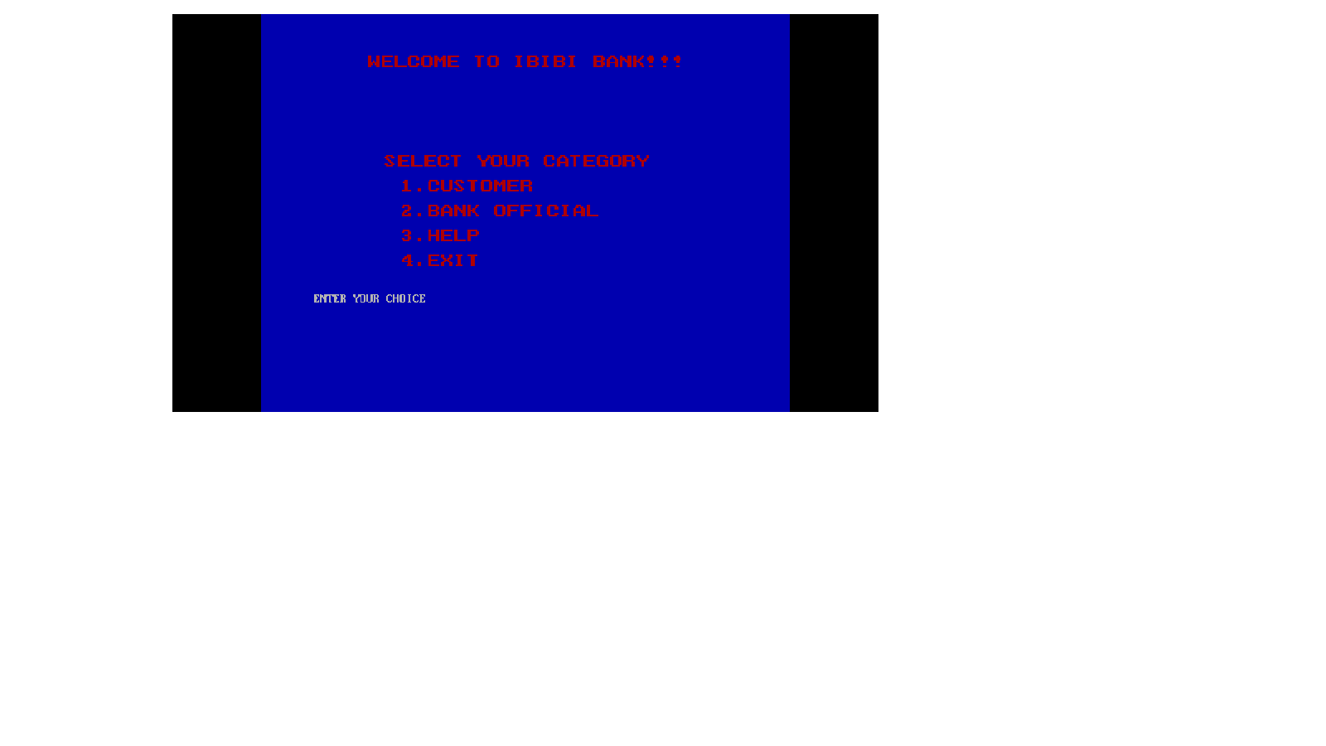

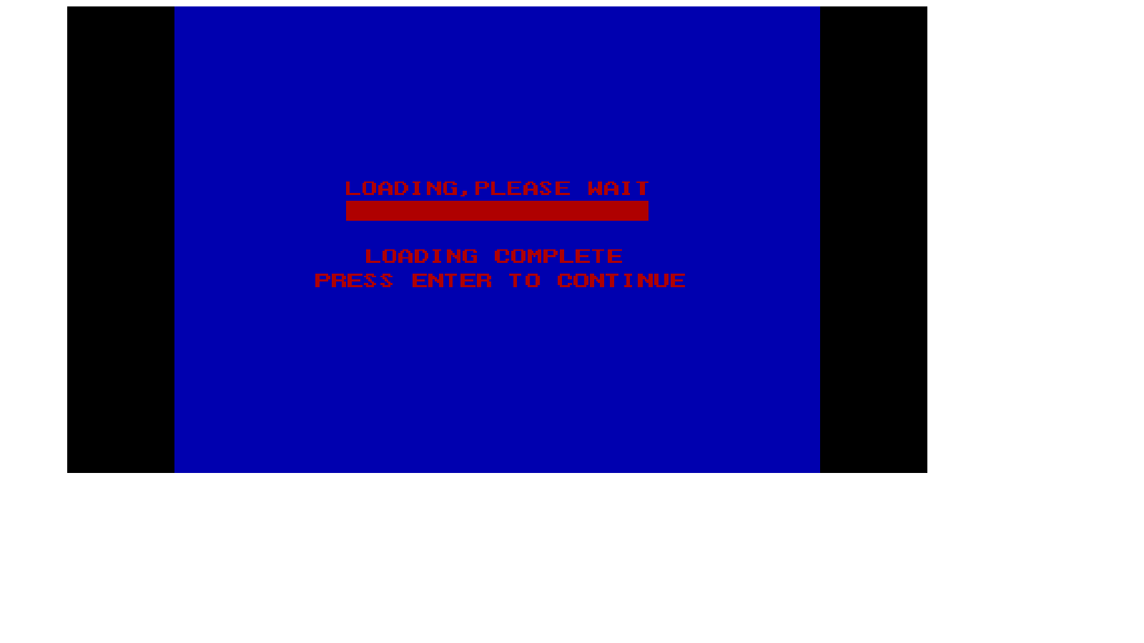

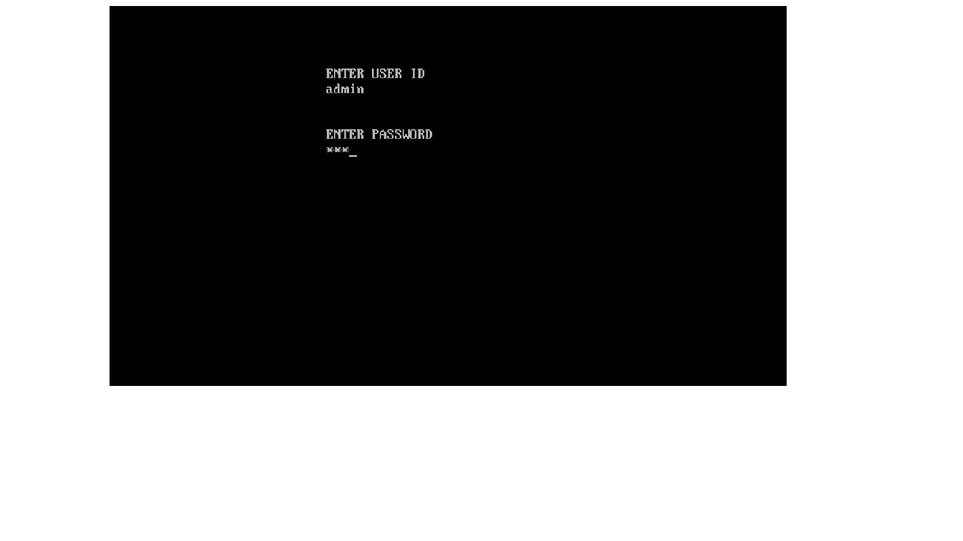

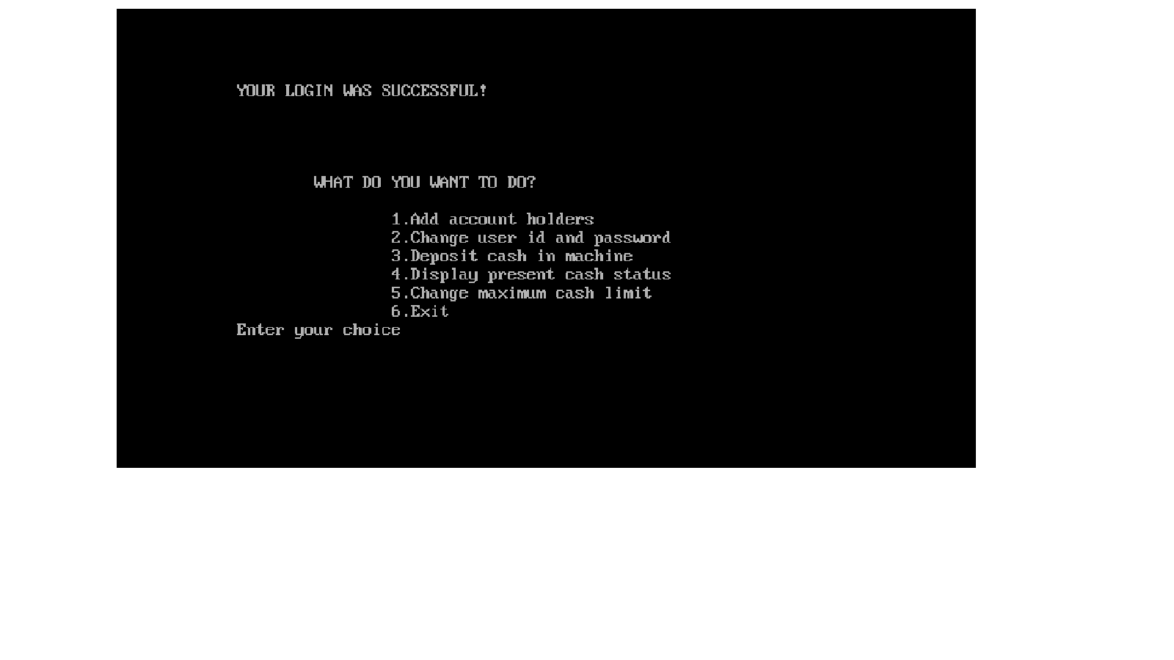

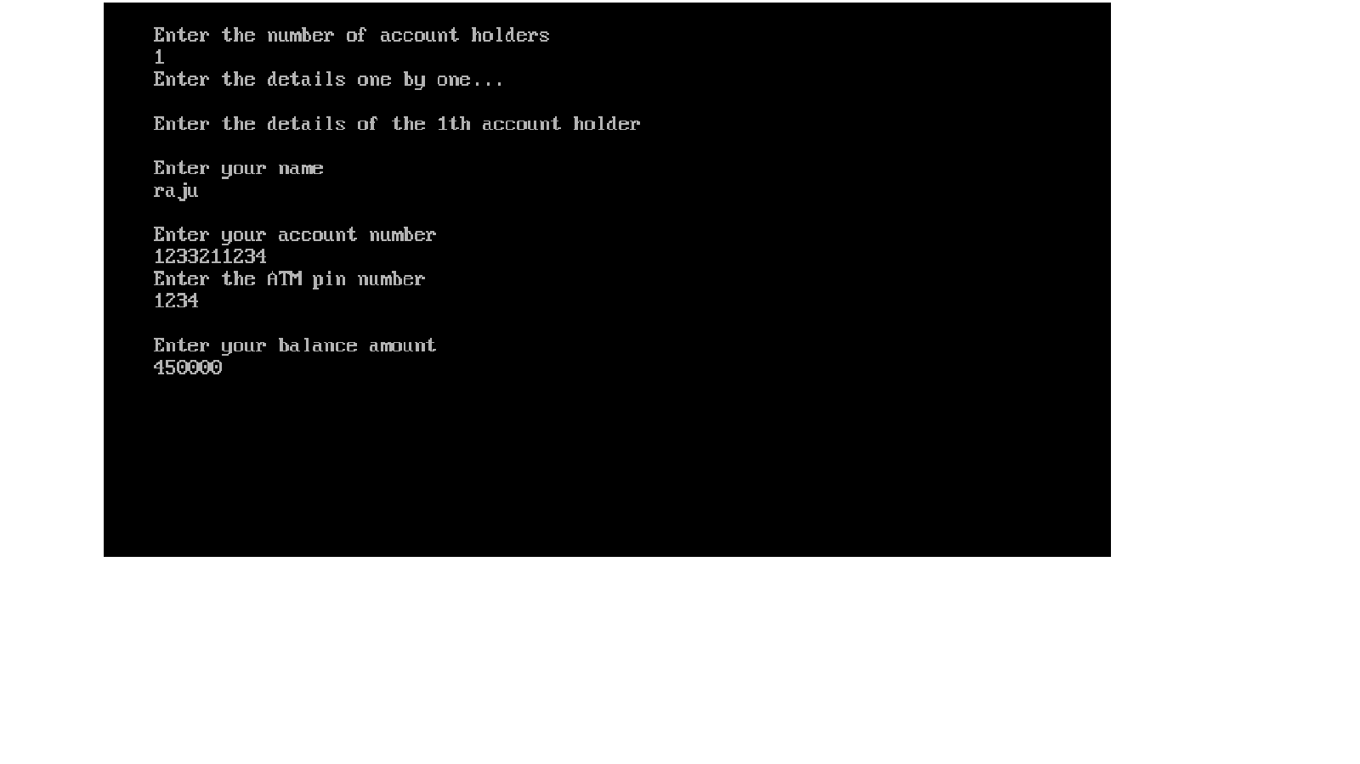

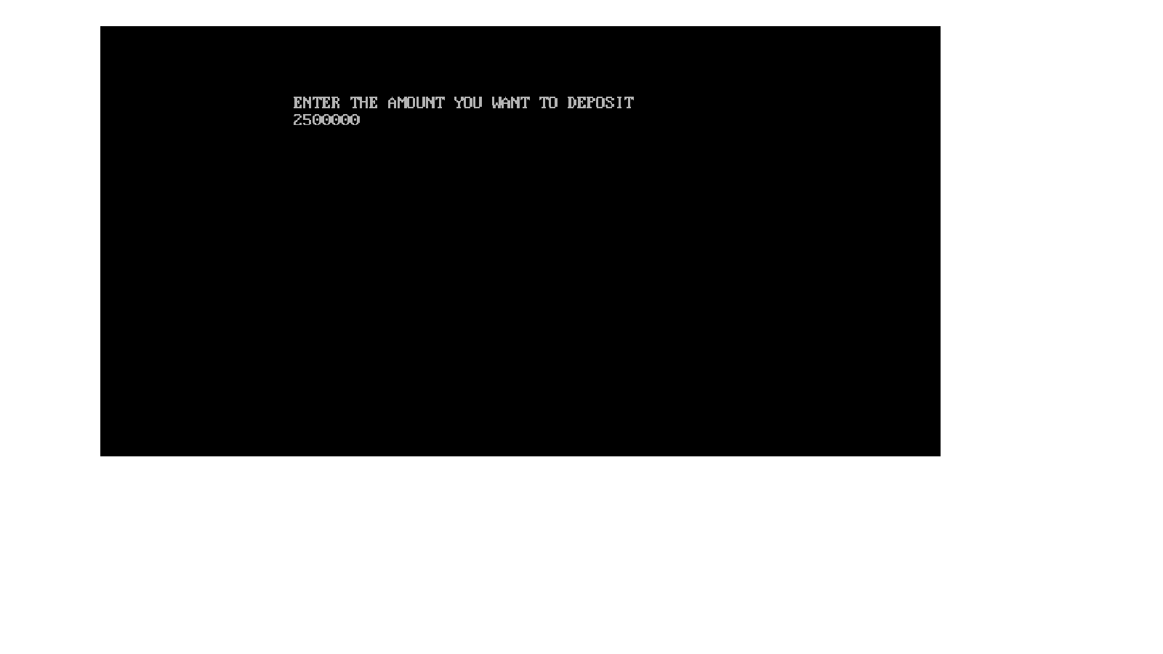

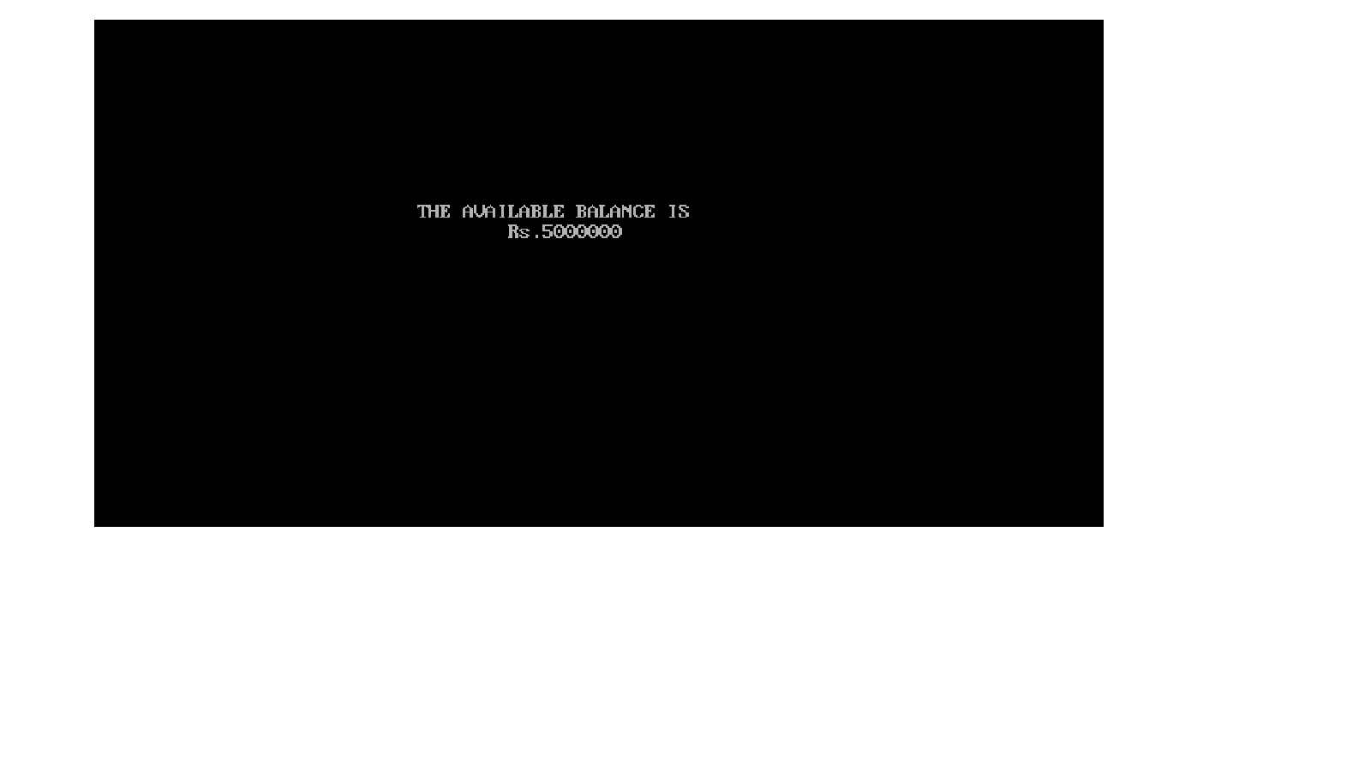

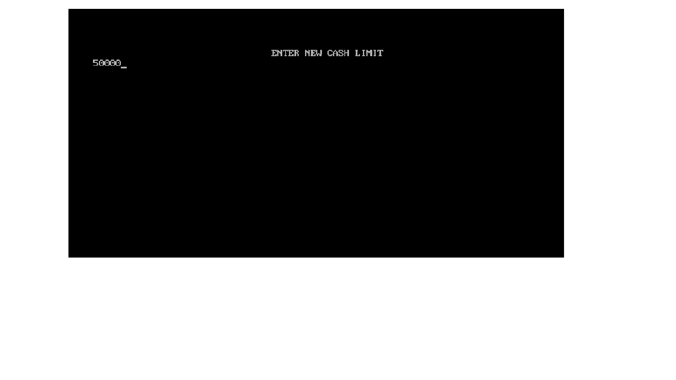

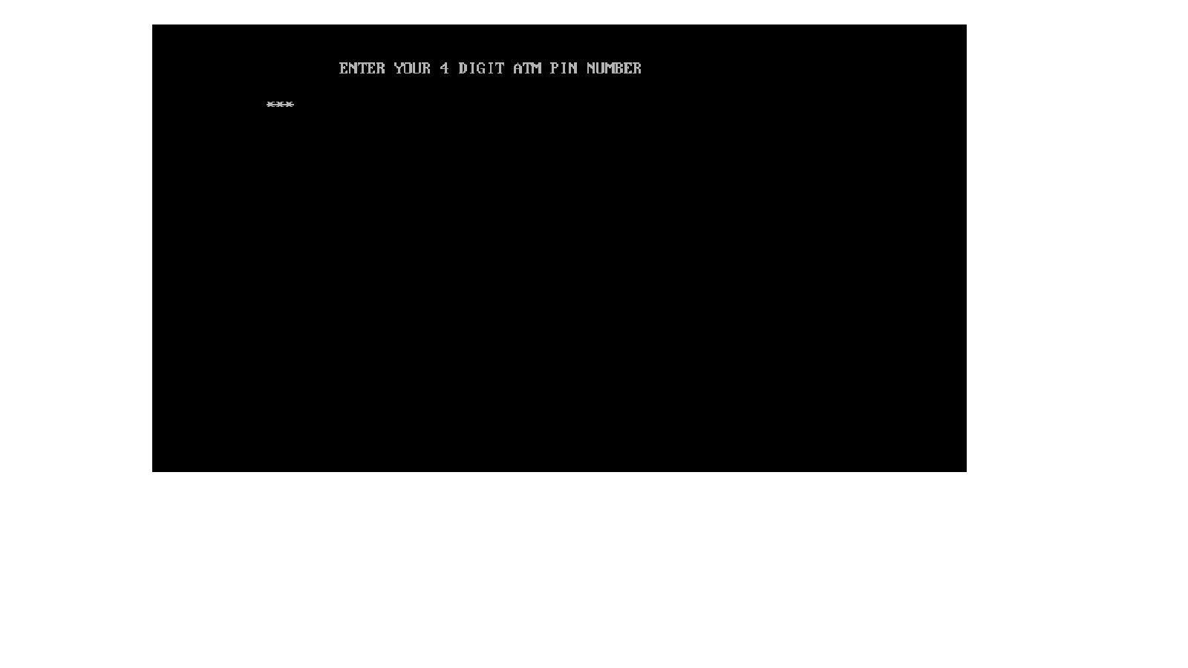

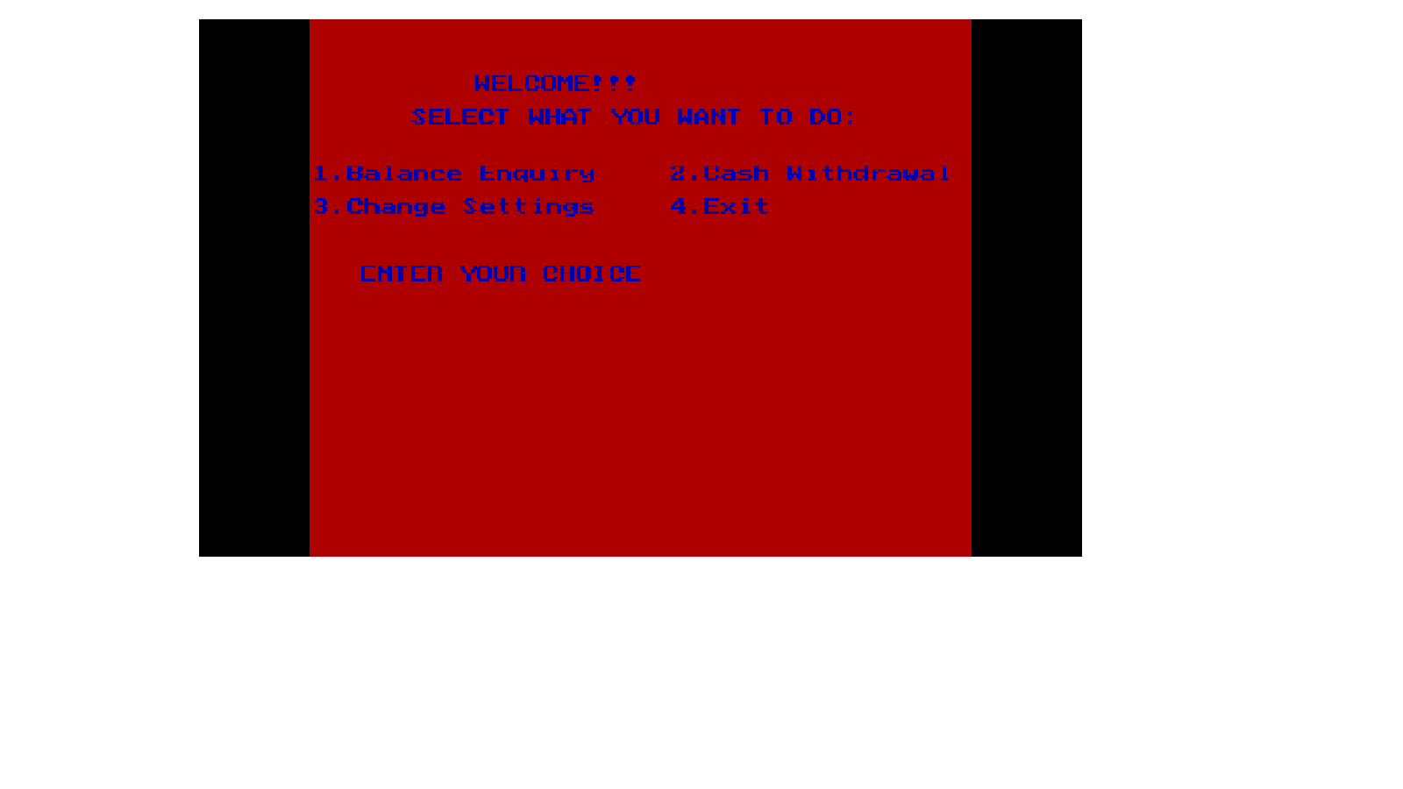

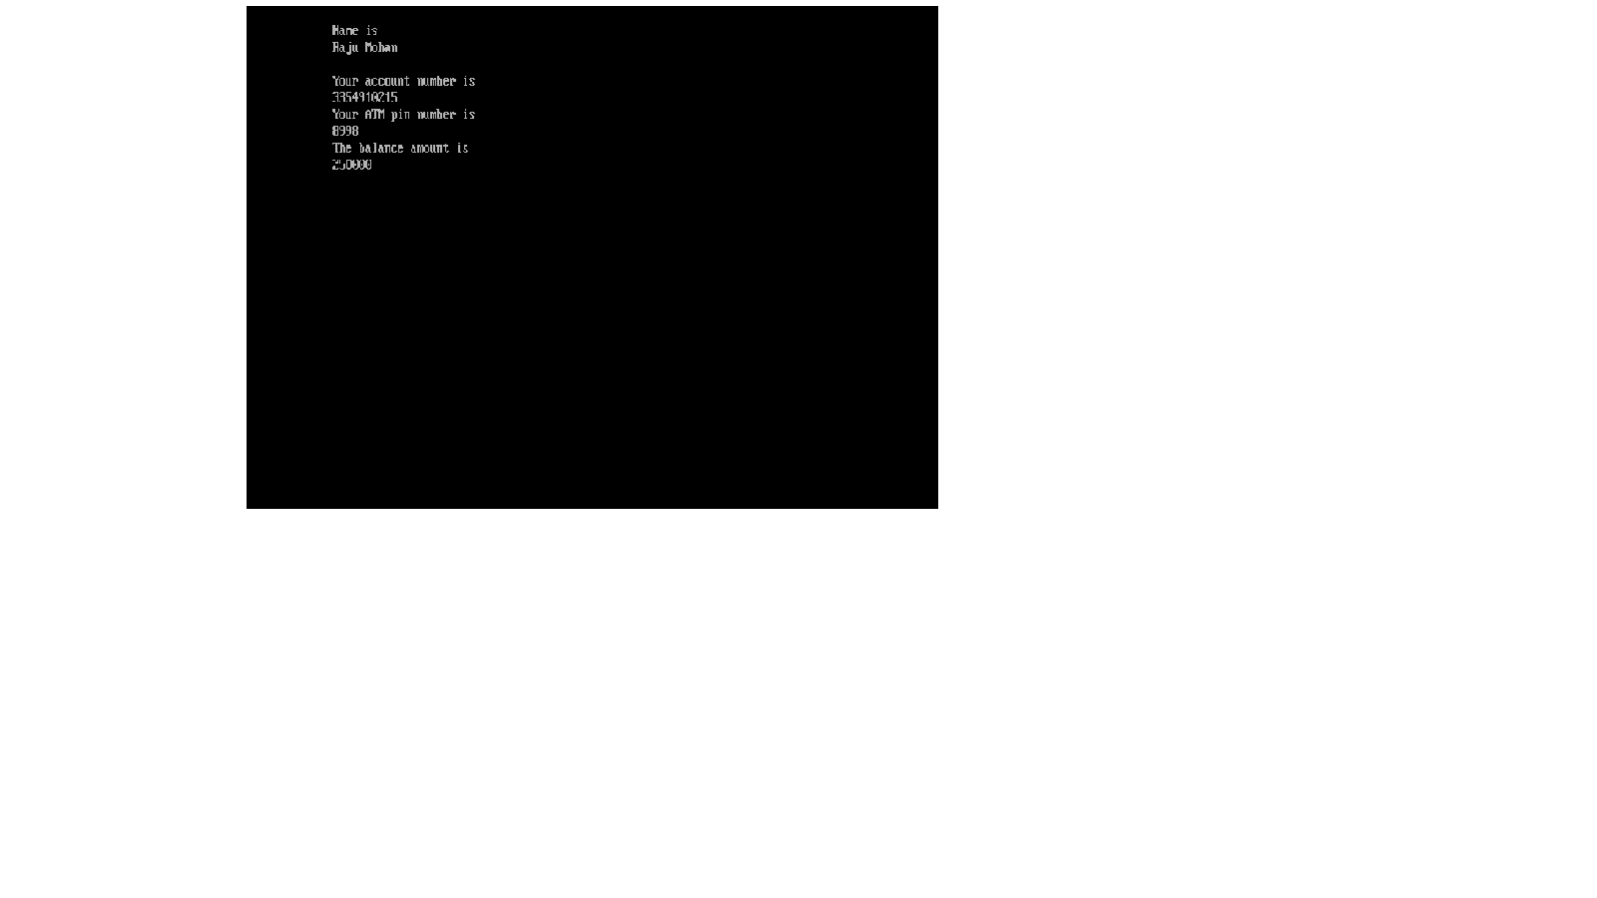

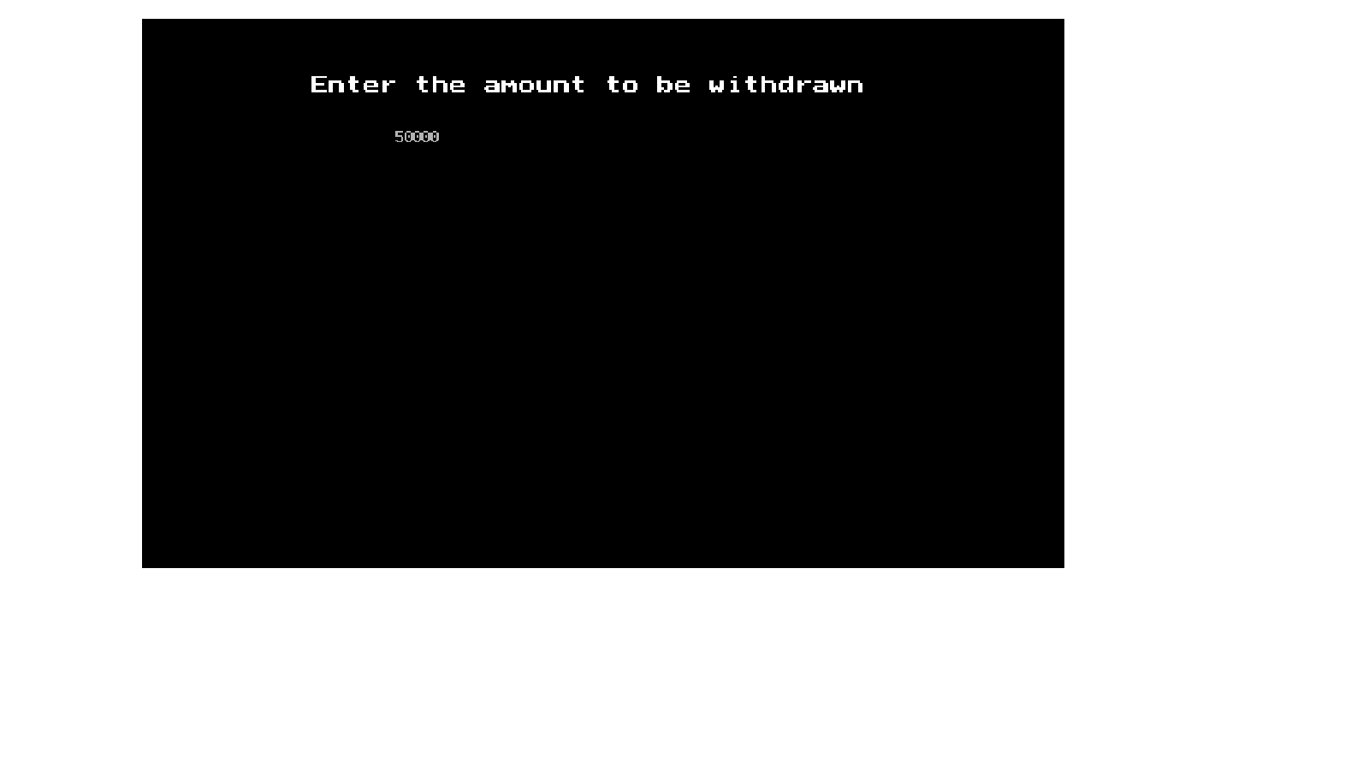

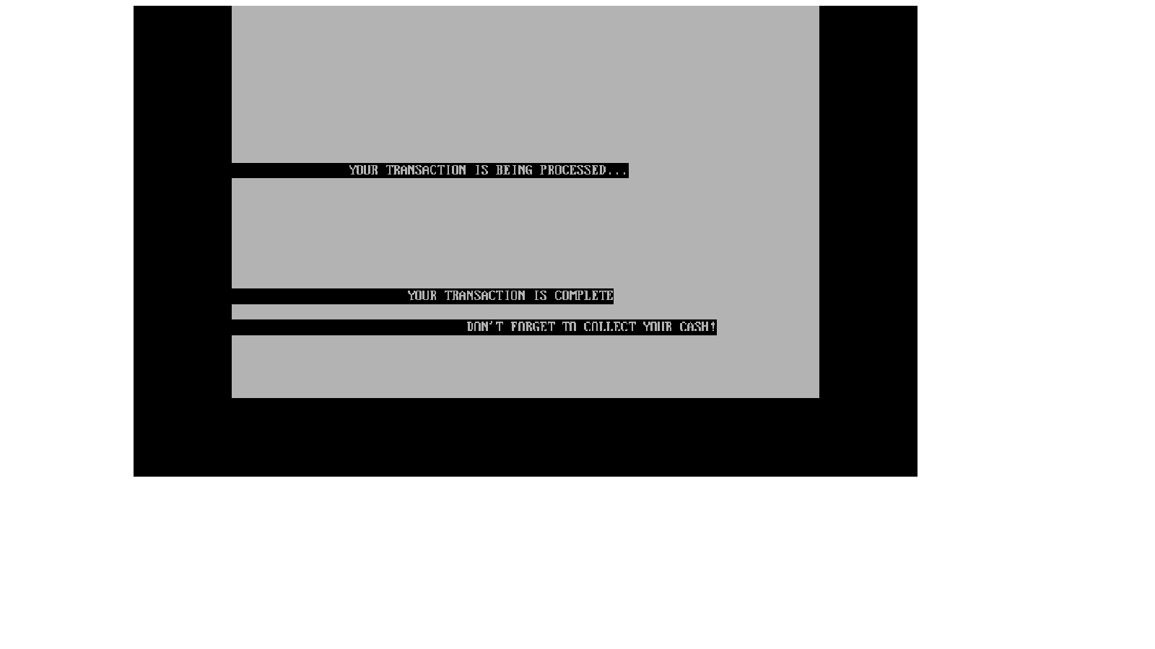

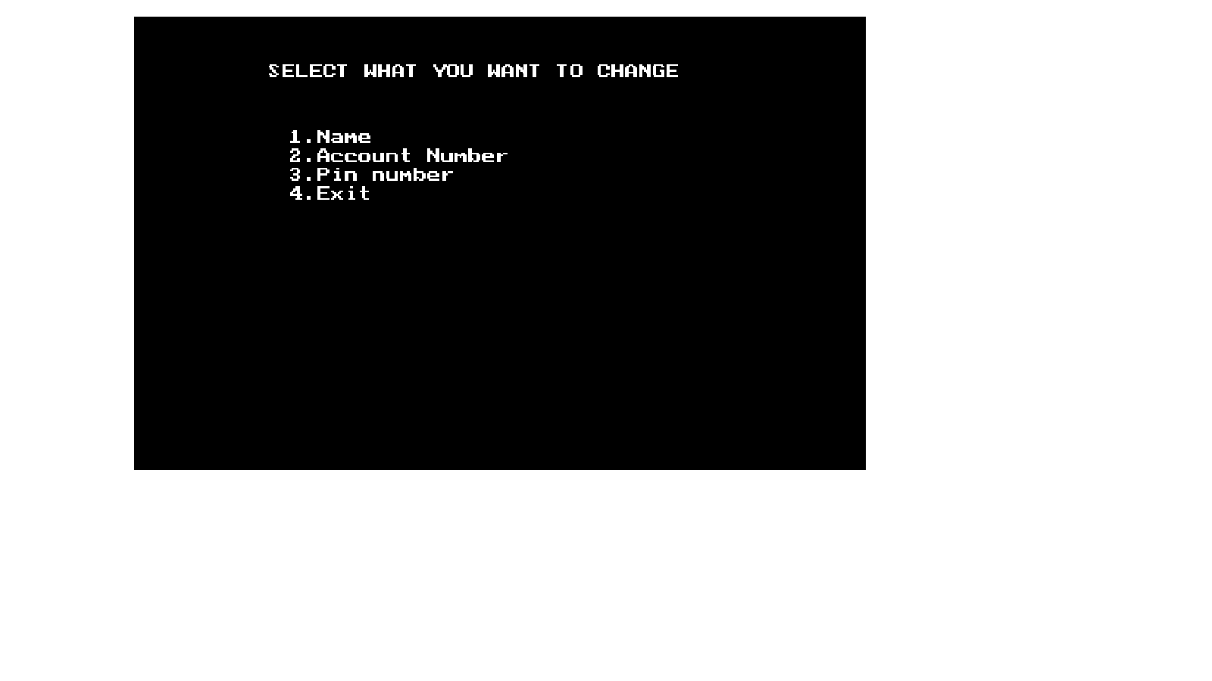

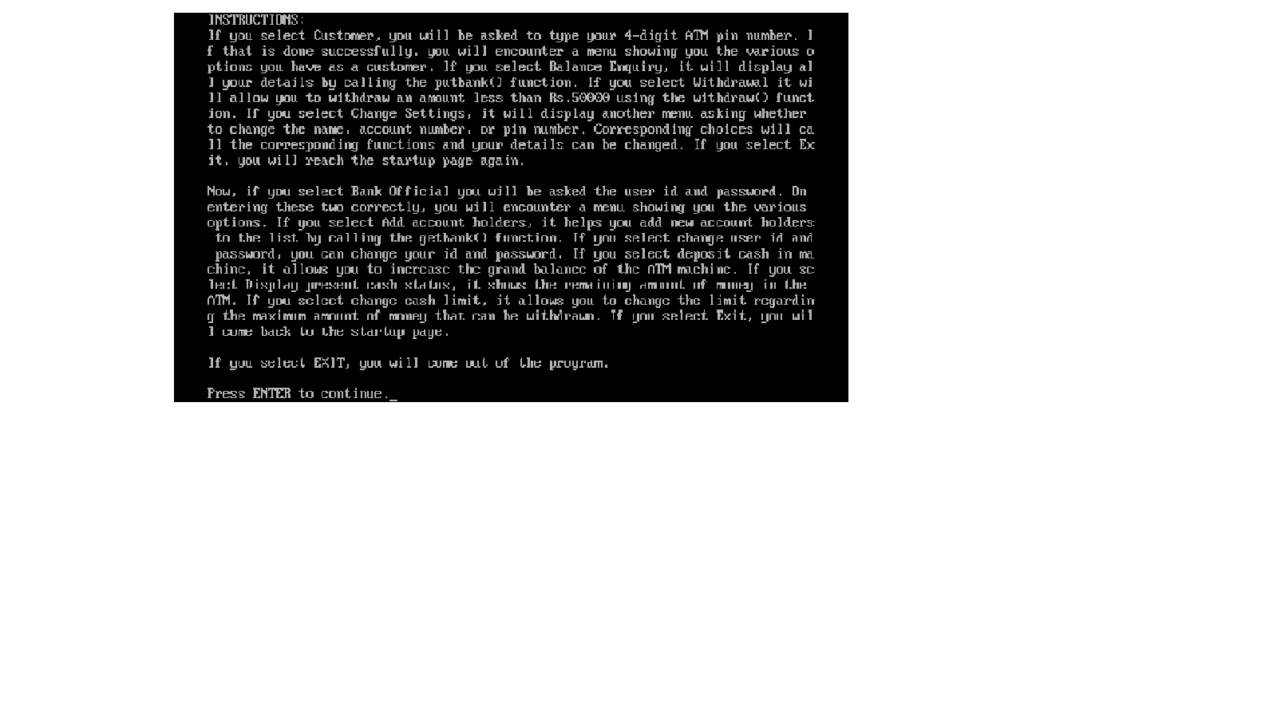

SHORTCOMINGS OF THE PROGRAM

One of the main shortcomings is that the bank doesn’t accept an account number which has more or less than 10 digits. The program also fails to include complex functions of an ATM system such as cash transfer, mini statements etc….

BIBLIOGRAPHY

* Computer Science with C++ class XII by Sumita Arora
* Wikipedia
* [www.cplusplus.com](http://www.cplusplus.com)
* [www.stackoverflow.com](http://www.stackoverflow.com)
* www.bytes.com